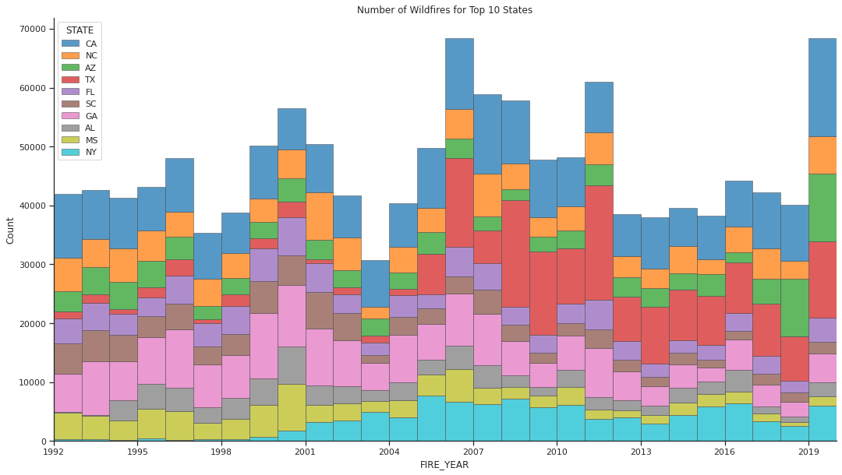 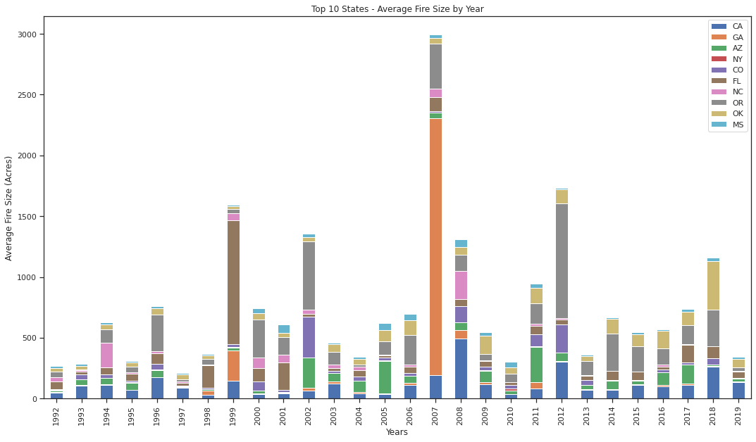

***Figure 1: Number of Wildfires for Top 10 States By Year Figure 2: Average Fire Size For Top 10 States By Year***

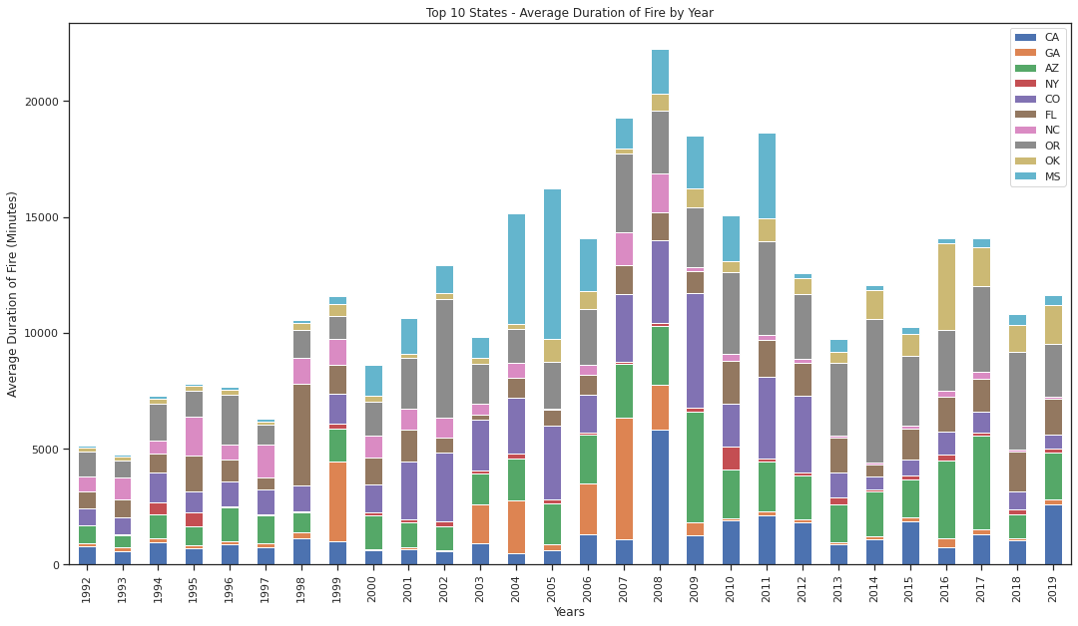

***Figure 3: Average Duration of Wildfires for Top 10 States By Year***

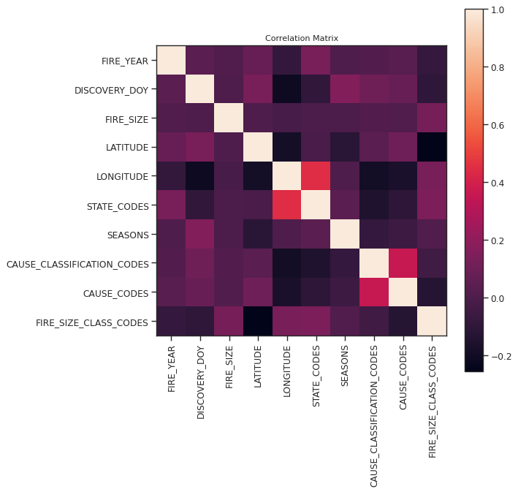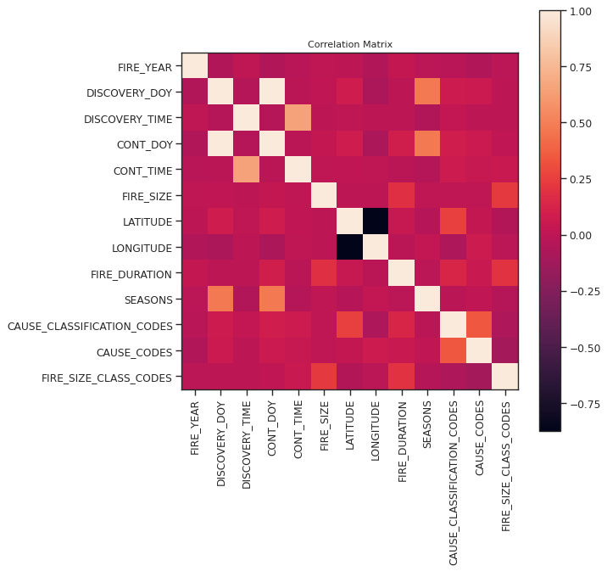

***Figure 4: Correlation Matrix for Top 10 States Figure 5: Correlation Matrix for California Wildfire Features***